Review VS

* New Feature:
  1. New for Debugger in VS 2013

[~~http://msdn.microsoft.com/zh-cn/library/01xdt7cs.aspx~~](http://msdn.microsoft.com/zh-cn/library/01xdt7cs.aspx)

[~~http://msdn.microsoft.com/en-us/library/hh704261(v=vs.120).aspx~~](http://msdn.microsoft.com/en-us/library/hh704261(v=vs.120).aspx)

* + - ~~Examine return values of method calls~~

[~~http://msdn.microsoft.com/en-us/library/dn323257(v=vs.120).aspx~~](http://msdn.microsoft.com/en-us/library/dn323257(v=vs.120).aspx)

* + - IntelliTrace

<http://msdn.microsoft.com/en-us/library/dd264915.aspx>

* + - ~~CodeLens~~

[~~http://msdn.microsoft.com/en-us/library/dn269218.aspx~~](http://msdn.microsoft.com/en-us/library/dn269218.aspx)

* + - * ~~Shortcut Alt + num~~
      * ~~Code Reference~~
      * ~~Incoming changes, All changes~~
      * ~~Authors~~
      * ~~Test Status~~
    - ~~Code Maps~~

[~~http://msdn.microsoft.com/en-us/library/dn194476.aspx~~](http://msdn.microsoft.com/en-us/library/dn194476.aspx)

* + - Generate Sequence Diagram
  1. UML  
     <http://msdn.microsoft.com/zh-cn/library/vstudio/dd409390(v=vs.110).aspx>  
     <http://msdn.microsoft.com/zh-cn/library/vstudio/dd323862(v=vs.110).aspx>
  2. Small Fresh
     + ~~Auto Run Unit Test~~
     + ~~Navigate To (Ctrl+,). Improvements include live result previewing and a streamlined inline UI experience.~~
  3. Other
     + ~~XAML design tools~~

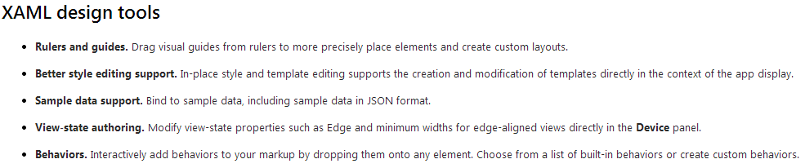

* Work:
  1. How to use Immediate window ($ReturnValue, 1 + 3)
  2. Verifying Code by Using UI Automation  
     [http://msdn.microsoft.com/en-us/library/dd286726.aspx#VerifyingCodeUsingCUITCreate](http://msdn.microsoft.com/en-us/library/dd286726.aspx%23VerifyingCodeUsingCUITCreate)
  3. Analyzing Application Quality  
     <http://msdn.microsoft.com/en-us/library/dd264897.aspx>
  4. xx
* Reference Website
  1. [What’s New in Visual Studio 2013](http://msdn.microsoft.com/en-us/library/bb386063.aspx)
  2. [What's New in Developer Quality and Diagnostic Tools in Visual Studio 2013](http://msdn.microsoft.com/en-us/library/hh704261.aspx)
  3. [What’s New for the Debugger in Visual Studio 2013](http://msdn.microsoft.com/en-us/library/01xdt7cs.aspx)
  4. xx